SLIP-ON STREET LEGAL EXHAUST SYSTEM for the VESPA GTS 250 (2005 - 2011)
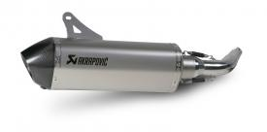
The Slip-On is the first stage in transforming your exhaust system. In addition to increasing your power, the Akrapovič Slip-On system gives your scooter a distinctive deeper sound and also changes its visual appearance. Even from afar you can see and hear that this is no mass-produced system. This system was developed based on rich experience and the result is a product that suits a scooter perfectly. Installation is a snap. Adding the optional catalytic converter makes the Slip-On exhaust system street legal.

